**Flow Chart of the Online Puja Permission**

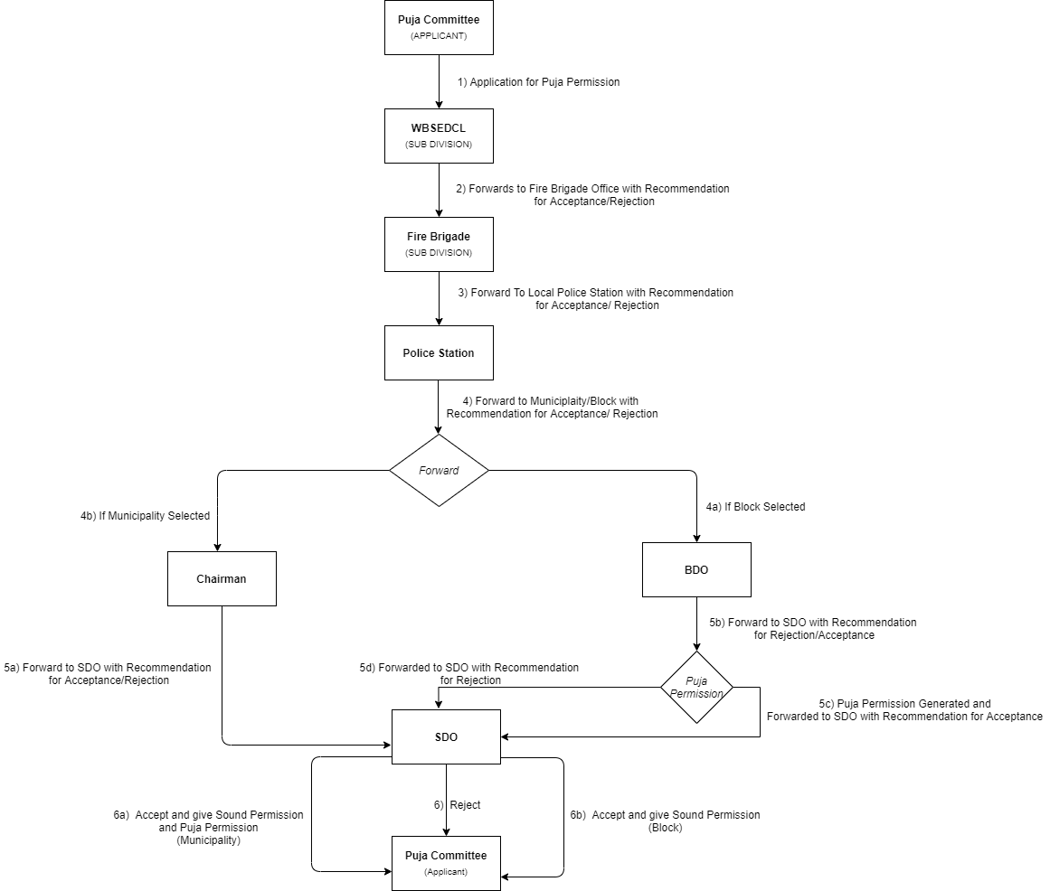

**Description:-**

At first Puja Committee Need to be registered to the service plus Portal.

**Step 1:** Then Apply For Puja Permission Service

**Step 2:** Application goes to **WBSEDCL.**

**WBSEDCL** forward the application with proper remark (NOC) to **Fire Brigade** if application is correct and valid.

**Step 3:** **Fire Brigade** forward the application with proper remark (NOC) to **Local Police Station** if application is correct and valid.

**Step 4:** **Local Police Station** forward the application with proper remark (NOC) to

**4b) Block / 4a) Municipality** depending upon the (Rural /Urban) area if application is correct and valid.

**Step 5:**

**5a)** **Municipality** forward the application with proper remark (NOC) to **SDO.**

**5b)** Block forwards the application to SDO.

**5c) Block** generates puja permission certificate and forward the application with proper remark (Final Permission) to **SDO.**

**Step 6:** Certification Generation by **Block/** for **Municipality and Block.**

**Step 6a:** **SDO** givesSound permission & Final permission for **Municipality** area.

**Step 6b:** **SDO** givesSound permission only for **Block** area**.**